PathWest Laboratory Medicine WA
Freedom Of Information Statement

Date: January 2024
Version 1.0

Contents
PathWest purpose, vision and values 3
Purpose 3
Vision 3
Values - CARE 3
PathWest Structure and Function 3
Enabling legislation 3
Accountable authority 4
Responsible Minister 4
Sharing responsibilities with other agencies 4
PathWest Service Delivery 6
Documents Held by PathWest 6
How to apply for access to information. 7
Costs 7

Version | Date | Author | Comments | Endorsement | Approval |  Dated
1.0 | January 2024 | Elizabeth Gregory |  | Nicola Chisholm  January 2024

Document No.

PathWest purpose, vision and values

Purpose
Improving the health, wellbeing and safety of our communities.

Vision
PathWest is a leader in our field and positively impacts our society and environment through the pursuit of excellence and innovation.

Values - CARE
- CARE for our communities and our staff
Our services exist to care for our communities and keep them healthy and safe. We foster a caring culture with each other and those we serve.
- ACCOUNTABILITY for our actions
We acknowledge our commitments and keep our promises. We take responsibility for our actions and our role in delivering excellent outcomes.
- RESPECT for ourselves and others
Our differences and uniqueness are embraced. By respecting who we work with and engage with, we create a safe and productive environment.
- EXCELLENCE at all times
What we do affects lives. We recognise the need to foster innovation and perform our duties and tasks to the best of our abilities and to the highest standards.

PathWest Structure and Function

Enabling legislation
The Health Services Act 2016 WA (HSA 2016) introduced changes to the governance of the WA health system by clarifying roles, responsibilities, and accountabilities and by devolving decision making to the local level.
Section 32 of the HSA 2016 provides for the establishment of Health Service Providers (HSPs). PathWest was established as a Board-governed HSP by the Minister for Health under section 32(1)(b) of the HSA 2016 on 1 July 2020.
Section 70(1)(b) of the HSA 2016 stipulates that the PathWest Board is the governing body of the statutory authority and is to perform or exercise all the functions of PathWest under this Act or any other written law.
Communication between PathWest and the Minister for Health, Parliamentary representatives, Ministers, and the WA health system is governed by a Communication Agreement, with clear lines of accountability and responsibility noted within.

Accountable authority
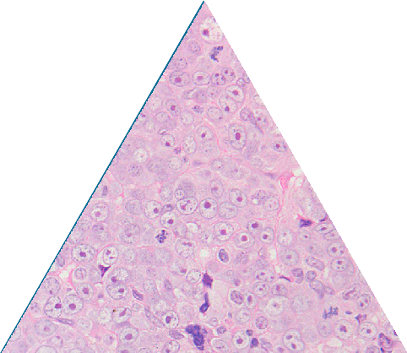
The PathWest Board is the accountable authority for PathWest.

Responsible Minister
PathWest is responsible to the Western Australian Minister for Health; Mental Health.

Sharing responsibilities with other agencies
PathWest works closely with several government and non-government agencies to deliver pathology and forensic services for the State to achieve the targets set out in the WA Health 2022-23 Outcome Based Management Key Performance Indicator Data Definition Manual

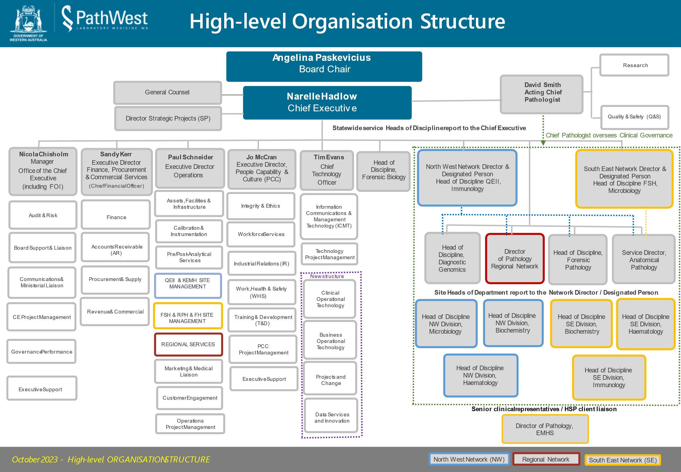

PathWest Service Delivery
PathWest is the statewide provider of public pathology and forensic services within the WA health and justice systems.
PathWest services all public hospitals from Kununurra in the north through to Esperance in the south, making our services accessible to all Western Australians.

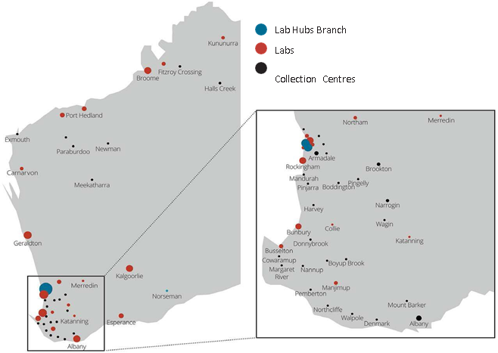
PathWest provides the WA community with a broad range of pathology services covering routine, complex and rare tests, as well as commercial testing services and diagnostic pathology testing in various laboratory medicine disciplines, such as pre- analytical, anatomical pathology, biochemistry, haematology, microbiology, diagnostic genomics, immunology, forensic pathology, and forensic biology.

Documents Held by PathWest
The types of information held by PathWest include:
- pathology results
- patient information, bulletins and pamphlets
- publications relating to health planning and management
- contract and tender records
- minutes and agendas
- general administrative records
- financial and budget records
- human resource records.

How to apply for access to information.
Access to information can be made through a Freedom of Information (FOI) application that involves the lodgement of a written request. The written request must provide sufficient detail to enable the application to be processed, including contact details and an Australian address for correspondence.
PathWest will consider all applications for information and, where possible release, documents outside the FOI process. If this is not possible, PathWest will assist the requestor with the process of obtaining the document under FOI.
In the case of an application for amendment or annotation of personal information it is required that the request include:
- detail of the matters in relation to which the applicant believes the information is inaccurate, incomplete, out of date or misleading
- the applicant’s reasons for holding that belief
- detail of the amendment that the applicant wishes to have made.

Applications should be addressed to the Freedom of Information Office and can be made in person, by mail, email or facsimile.
Mail: PathWest Freedom of Information Office
Locked Bag 100, Palmyra DC WA 6961
Email: PathWest.FOI@health.wa.gov.au
All requests for information can be granted, partially granted or may be refused in accordance with the Western Australian Freedom of Information Act 1992. The applicant can appeal if dissatisfied with the process or the reasons provided, in the event of an adverse access decision.
More information on the Freedom of Information Act 1992 can be found here.

Costs
No charges are incurred for requests for personal information or amendment of personal information about an applicant.
Application for documents that are not personal may incur a fee. Maximum charges are as follows:
Description | Charge
Application fee | $30
Staff time dealing with the application | $30 per hour
Photocopies | 20 cents each
Duplicating a tape, film or computer information | Actual cost
Delivery, packaging and postage | Actual cost

This document can be made available in alternative formats on request for a person
with a disability.
© PathWest Laboratory Medicine WA 2024
Copyright to this material is vested in the State of Western Australia unless otherwise indicated. Apart from any fair dealing for the purposes of private study, research, criticism or review, as permitted under the provisions of the Copyright Act 1968, no part may be reproduced or re-used for any purposes whatsoever without written permission of the State of Western Australia.

